Sci2 64 bit builds on Win, Mac, Linux

Sci2 64 bit build on Windows

Current Issue

Any attempts to run the 64 bit Windows version of the application by double clicking the application fails to launch and generates the following exception in the log.

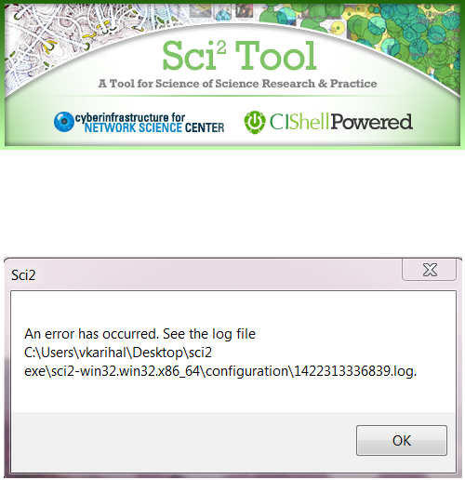

It generates the following log file. It is a big log file. I am just copying the starting portion of it.

!SESSION 2015-01-20 13:49:43.986 -----------------------------------------------
eclipse.buildId=unknown
java.version=1.7.0_72
java.vendor=Oracle Corporation
BootLoader constants: OS=win32, ARCH=x86_64, WS=win32, NL=en_US
Command-line arguments: -os win32 -ws win32 -arch x86_64

!ENTRY org.eclipse.osgi 4 0 2015-01-20 13:49:45.107
!MESSAGE An error occurred while automatically activating bundle org.eclipse.ui.workbench (73).
!STACK 0
org.osgi.framework.BundleException: The activator org.eclipse.ui.internal.WorkbenchPlugin for bundle org.eclipse.ui.workbench is invalid
at org.eclipse.osgi.framework.internal.core.AbstractBundle.loadBundleActivator(AbstractBundle.java:171)
at org.eclipse.osgi.framework.internal.core.BundleContextImpl.start(BundleContextImpl.java:679)
at org.eclipse.osgi.framework.internal.core.BundleHost.startWorker(BundleHost.java:381)
at org.eclipse.osgi.framework.internal.core.AbstractBundle.start(AbstractBundle.java:299)
at org.eclipse.osgi.framework.util.SecureAction.start(SecureAction.java:440)
at org.eclipse.osgi.internal.loader.BundleLoader.setLazyTrigger(BundleLoader.java:268)
at org.eclipse.core.runtime.internal.adaptor.EclipseLazyStarter.postFindLocalClass(EclipseLazyStarter.java:107)
at org.eclipse.osgi.baseadaptor.loader.ClasspathManager.findLocalClass(ClasspathManager.java:463)
at org.eclipse.osgi.internal.baseadaptor.DefaultClassLoader.findLocalClass(DefaultClassLoader.java:216)
at org.eclipse.osgi.internal.loader.BundleLoader.findLocalClass(BundleLoader.java:400)
at org.eclipse.osgi.internal.loader.SingleSourcePackage.loadClass(SingleSourcePackage.java:35)
at org.eclipse.osgi.internal.loader.BundleLoader.findClassInternal(BundleLoader.java:473)
at org.eclipse.osgi.internal.loader.BundleLoader.findClass(BundleLoader.java:429)
at org.eclipse.osgi.internal.loader.BundleLoader.findClass(BundleLoader.java:417)
at org.eclipse.osgi.internal.baseadaptor.DefaultClassLoader.loadClass(DefaultClassLoader.java:107)
at java.lang.ClassLoader.loadClass(Unknown Source)
at java.lang.Class.getDeclaredMethods0(Native Method)
at java.lang.Class.privateGetDeclaredMethods(Unknown Source)
at java.lang.Class.getDeclaredMethod(Unknown Source)
at org.eclipse.equinox.internal.ds.model.ServiceComponent.getMethod(ServiceComponent.java:148)
at org.eclipse.equinox.internal.ds.model.ServiceComponent.activate(ServiceComponent.java:245)
at org.eclipse.equinox.internal.ds.model.ServiceComponentProp.activate(ServiceComponentProp.java:146)
at org.eclipse.equinox.internal.ds.model.ServiceComponentProp.build(ServiceComponentProp.java:346)
at org.eclipse.equinox.internal.ds.InstanceProcess.buildComponent(InstanceProcess.java:588)
at org.eclipse.equinox.internal.ds.InstanceProcess.buildComponents(InstanceProcess.java:196)
at org.eclipse.equinox.internal.ds.Resolver.buildNewlySatisfied(Resolver.java:441)
at org.eclipse.equinox.internal.ds.Resolver.enableComponents(Resolver.java:213)
at org.eclipse.equinox.internal.ds.SCRManager.performWork(SCRManager.java:800)
at org.eclipse.equinox.internal.ds.SCRManager$QueuedJob.dispatch(SCRManager.java:767)
at org.eclipse.equinox.internal.ds.WorkThread.run(WorkThread.java:89)
at java.lang.Thread.run(Unknown Source)
Caused by: java.lang.NoClassDefFoundError: org/eclipse/swt/SWTError
at java.lang.Class.getDeclaredConstructors0(Native Method)
at java.lang.Class.privateGetDeclaredConstructors(Unknown Source)
at java.lang.Class.getConstructor0(Unknown Source)
at java.lang.Class.newInstance(Unknown Source)
at org.eclipse.osgi.framework.internal.core.AbstractBundle.loadBundleActivator(AbstractBundle.java:166)
... 30 more
Caused by: java.lang.ClassNotFoundException: org.eclipse.swt.SWTError
at org.eclipse.osgi.internal.loader.BundleLoader.findClassInternal(BundleLoader.java:513)
at org.eclipse.osgi.internal.loader.BundleLoader.findClass(BundleLoader.java:429)
at org.eclipse.osgi.internal.loader.BundleLoader.findClass(BundleLoader.java:417)
at org.eclipse.osgi.internal.baseadaptor.DefaultClassLoader.loadClass(DefaultClassLoader.java:107)
at java.lang.ClassLoader.loadClass(Unknown Source)
... 35 more
Root exception:
java.lang.NoClassDefFoundError: org/eclipse/swt/SWTError
at java.lang.Class.getDeclaredConstructors0(Native Method)
at java.lang.Class.privateGetDeclaredConstructors(Unknown Source)
at java.lang.Class.getConstructor0(Unknown Source)
at java.lang.Class.newInstance(Unknown Source)
at org.eclipse.osgi.framework.internal.core.AbstractBundle.loadBundleActivator(AbstractBundle.java:166)
at org.eclipse.osgi.framework.internal.core.BundleContextImpl.start(BundleContextImpl.java:679)
at org.eclipse.osgi.framework.internal.core.BundleHost.startWorker(BundleHost.java:381)
at org.eclipse.osgi.framework.internal.core.AbstractBundle.start(AbstractBundle.java:299)
at org.eclipse.osgi.framework.util.SecureAction.start(SecureAction.java:440)
at org.eclipse.osgi.internal.loader.BundleLoader.setLazyTrigger(BundleLoader.java:268)
at org.eclipse.core.runtime.internal.adaptor.EclipseLazyStarter.postFindLocalClass(EclipseLazyStarter.java:107)
at org.eclipse.osgi.baseadaptor.loader.ClasspathManager.findLocalClass(ClasspathManager.java:463)
at org.eclipse.osgi.internal.baseadaptor.DefaultClassLoader.findLocalClass(DefaultClassLoader.java:216)
at org.eclipse.osgi.internal.loader.BundleLoader.findLocalClass(BundleLoader.java:400)
at org.eclipse.osgi.internal.loader.SingleSourcePackage.loadClass(SingleSourcePackage.java:35)
at org.eclipse.osgi.internal.loader.BundleLoader.findClassInternal(BundleLoader.java:473)
at org.eclipse.osgi.internal.loader.BundleLoader.findClass(BundleLoader.java:429)
at org.eclipse.osgi.internal.loader.BundleLoader.findClass(BundleLoader.java:417)
at org.eclipse.osgi.internal.baseadaptor.DefaultClassLoader.loadClass(DefaultClassLoader.java:107)
at java.lang.ClassLoader.loadClass(Unknown Source)
at java.lang.Class.getDeclaredMethods0(Native Method)
at java.lang.Class.privateGetDeclaredMethods(Unknown Source)
at java.lang.Class.getDeclaredMethod(Unknown Source)
at org.eclipse.equinox.internal.ds.model.ServiceComponent.getMethod(ServiceComponent.java:148)
at org.eclipse.equinox.internal.ds.model.ServiceComponent.activate(ServiceComponent.java:245)
at org.eclipse.equinox.internal.ds.model.ServiceComponentProp.activate(ServiceComponentProp.java:146)
at org.eclipse.equinox.internal.ds.model.ServiceComponentProp.build(ServiceComponentProp.java:346)
at org.eclipse.equinox.internal.ds.InstanceProcess.buildComponent(InstanceProcess.java:588)
at org.eclipse.equinox.internal.ds.InstanceProcess.buildComponents(InstanceProcess.java:196)
at org.eclipse.equinox.internal.ds.Resolver.buildNewlySatisfied(Resolver.java:441)
at org.eclipse.equinox.internal.ds.Resolver.enableComponents(Resolver.java:213)
at org.eclipse.equinox.internal.ds.SCRManager.performWork(SCRManager.java:800)
at org.eclipse.equinox.internal.ds.SCRManager$QueuedJob.dispatch(SCRManager.java:767)
at org.eclipse.equinox.internal.ds.WorkThread.run(WorkThread.java:89)
at java.lang.Thread.run(Unknown Source)
Caused by: java.lang.ClassNotFoundException: org.eclipse.swt.SWTError
at org.eclipse.osgi.internal.loader.BundleLoader.findClassInternal(BundleLoader.java:513)
at org.eclipse.osgi.internal.loader.BundleLoader.findClass(BundleLoader.java:429)
at org.eclipse.osgi.internal.loader.BundleLoader.findClass(BundleLoader.java:417)
at org.eclipse.osgi.internal.baseadaptor.DefaultClassLoader.loadClass(DefaultClassLoader.java:107)
at java.lang.ClassLoader.loadClass(Unknown Source)
... 35 more
In the above error log file the two error messages I focus on are:-
- Error A: org.osgi.framework.BundleException: The activator org.eclipse.ui.internal.WorkbenchPlugin for bundle org.eclipse.ui.workbench is invalid
- Error B: java.lang.ClassNotFoundException: org.eclipse.swt.SWTError

Error A: OSGI framework
- Made me think the 64 bit OSGI container is corrupt
- The architecture filter mentions <arch>x86_64<arch>. I left it blank just to inspect if by not mentioning platform arch makes any difference. But it did not work.

Error B: SWT bundle (Standard Widget Toolkit)
- Goal A:- Made me think SWT library exist and is not able to load
- Goal B:- Made me think 64 bit SWT library does not exist in the current project
- Goal C:- Made me think 64 bit SWT library is corrupt

Goal A: - SWT library exist and is not able to load
- I looked up for SWTError class file.

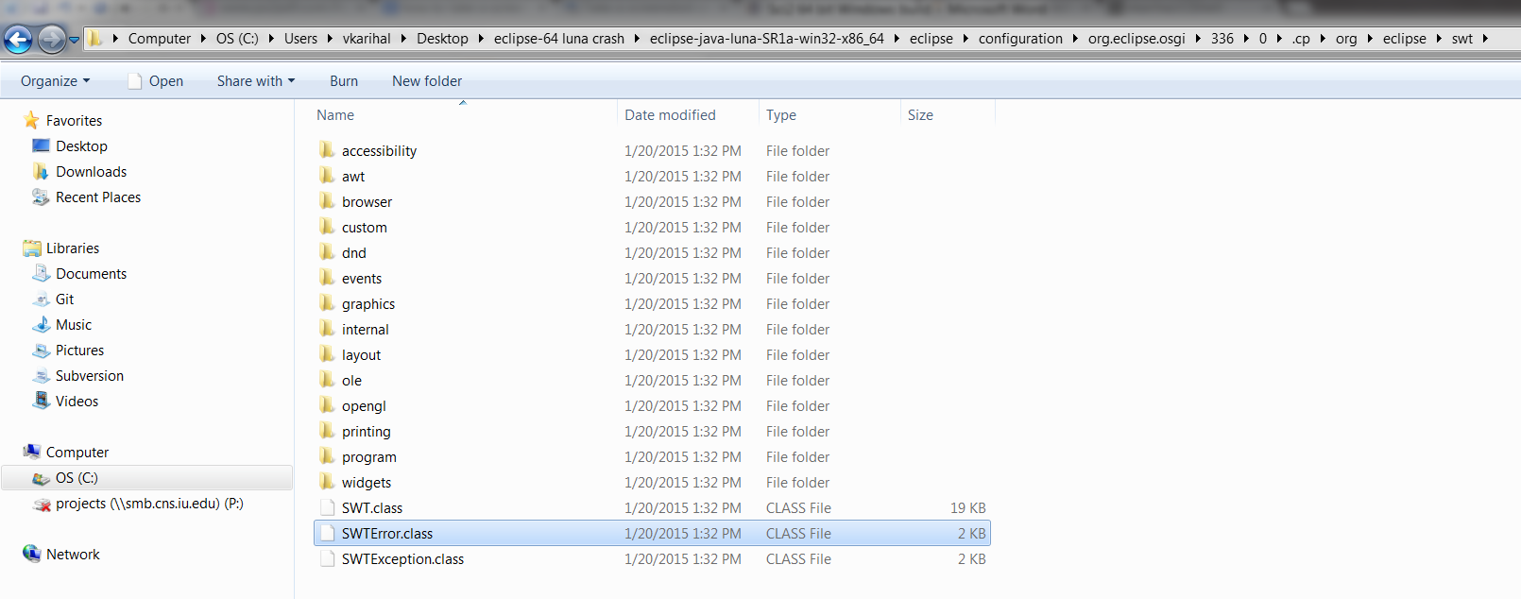

- I added the above path for SWTError.class to classpath for the project.
- But it failed to resolve any issues.

Goal B: - 64 bit SWT library does not exist in the current project
- I check the target platform for missing SWT 64 bit jar.

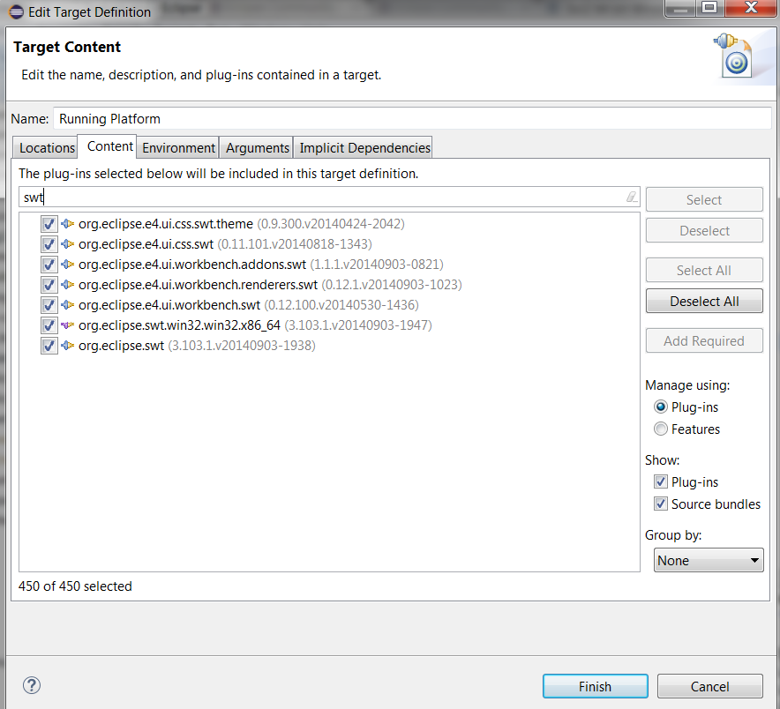

- In the plug in tab, I typed SWT and saw the 64 bit SWT bundle is included.

Goal C: - 64 bit SWT library is corrupt
- The 64 bit library comes with the eclipse bundles. It made me think SWT64 bit library included above should not be corrupt. Since if it is corrupt, the entire eclipse is corrupt which is highly unlikely.
- Since the 32 bit SWT library works fine.

So, the next step I took was put my questions on a few eclipse and stackoverflow communities.

Suggestions:-
- Suggestion A: - Can have issues with AbstractBundle
- Suggestion B: - Sci2 app.exe is somehow being run by 32 bit JVM instead of 64 bit JVM.
- Suggestion C: - Target OSGI platform might be corrupted.

Suggestion A: - Can have issues with AbstractBundle

- I researched on AbstractBundle. Got to understand AbstractBundle often belongs to eclipse 3.3 platforms. So after my initial research I concluded it should not be a reason behind 64 bit Sci2.exe failing.

Suggestion B: - Sci2 app.exe is somehow being run by 32 bit JVM instead of 64 bit JVM.
- I manually ran Sci2 app.exe with 64 bit JVM.

app.exe -vm "C:\Program Files\Java\jre7\bin\java.exe"
app.exe -vm "C:\Program Files\Java\jre7\bin\java.exe" -d64

- But it made no difference at all. Sci2.exe again crashed.

Suggestion C: - Target OSGI platform might be corrupted.
- I started Sci2 with OSGI shell.
- Command: sci2.exe -noExit -console
- The app crashed but the OSGI shell stayed alive because of noExit parameter.
- Then in the osgi shell I looked up for SWT libraries. And I did not saw any 64 bit SWT library.

osgi> ss org.eclipse.swt

Framework is launched.

id State Bundle
70 RESOLVED org.eclipse.swt_3.7.2.v3740f

- So, I concluded equinox container does not contain SWT 64 bit bundle.
- I manually added 64 bit and installed it using the OSGI shell. It got installed but I was not able to START the 64 bit SWT bundle on its own. The individual bundle cannot come into a RESOLVED state on their own.
- So next I inspected the target platform, since I got the idea that the bundle needs to be launched by the target platform’s equinox launcher.
- In target platform equinox environment’s feature.xml I found plugin specification for 64 bit launcher and 64 bit SWT Windows bundles is missing.
- Once I added specifications for missing bundles and build the project again. The resulting Sci2 64 bit Windows exe worked.

<plugin
id="org.eclipse.swt.win32.win32.x86_64"
os="win32"
ws="win32"
arch="x86_64"
download-size="0"
install-size="0"
version="0.0.0"
fragment="true"
unpack="false"/>

<plugin
id="org.eclipse.equinox.launcher.win32.win32.x86_64"
os="win32"
ws="win32"
arch="x86_64"
download-size="0"
install-size="0"
version="0.0.0"
fragment="true"/>

Sci2 64 bit build for Mac

- Executed without errors

Sci2 64 bit build for Linux
- Installed Vmware
- Installed Ubuntu OS. Tested 64 bit Sci2 linux build on it. It executed without errors.

