Step-by-step guide (Steve + Vivek)
The following steps should be done at a bash shell. Commands follow the step description. Replace repository and file names with your own as needed.
- Get a list of people who've authored commits to the repository. Put it into a file.
  - svn log --quiet <uri to svn repo> | grep -E "r[0-9]+ \| .+ \|" | cut -d'|' -f2 | sed 's/^ //' | sort | uniq > <authors file>
- Edit authors.txt so it follows the correct format (example given below).
  - nano <authors file>
    - adhsimps = Adam Simpson <adhsimps@indiana.edu>
dhalsey = Daniel Halsey <dhalsey@indiana.edu>
kongch = Chin Hua Kong <kongch@indiana.edu>
scorenfl = Steve Corenflos <scorenfl@indiana.edu>
- Create the git clone of the repository. Be sure to use the authors file to help git track commit ownership.
  - git svn clone <uri to svn repo> --authors-file=<authors file> --no-metadata <git repo name>
- Open a web browser and create repository at github.iu.edu.
  - https://github.iu.edu/organizations/CNS/repositories/new
  - Double-check to make sure repository is set to "private" if it needs to be private.
  - Select option to: "Initialize this repository with a README"
- Go back to your terminal window and add the new github repo as a remote.
  - git remote add origin git@github.iu.edu:CNS/<git repo>.git
  - Make sure you run the above command from the folder which contains .git file.
- Update from github. As long as README.md doesn't already exist in your repo, this should merge seamlessly.
  - git pull origin master. Before this step you need to have a public SSH key. Look at the bottom of the screen to look for steps for generating a SSH key.
- Double-check your repo to make sure everything is how you'd like, and then push to the server.
  - git push
You should now have a git repository complete with svn history ongithub.iu.edu.

Fork
A fork is a copy of the repository. Forking a repository allow you to commit changes without affecting the original project.
Go to the repository which you wish to fork.
You shall see a Fork symbol on the top right hand corner. Click it
And you have a local copy of repo in your git account.
In the end you might want to send a pull request to the project owner.
If the project owner likes your work, they might pull your fix into original repo.

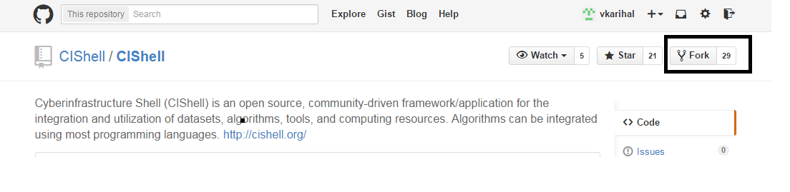
Environmental Changes:-

Add JDK64 bit and JRE 64 bit to your machine.
Use Eclipse Luna instead of Eclipse Kepler
Change the version of Tycho in the POM file in your parent CIShell folder.
Change it from 0.14.1 to 0.18.1

Parent CIShell pom.xml location:-

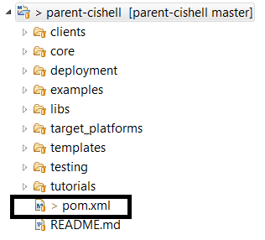

Double click the pom.xml. Search for tychoVersion tag.
Change the version from 0.14.1 to 0.18.1

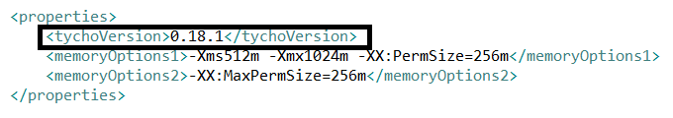

How to generate a SSH key

You shall require a bash shell to execute the following commands. Putty should work.

https://help.github.com/articles/generating-ssh-keys/

ssh-keygen -t rsa -C "your_email@example.com"
Enter passphrase (empty for no passphrase): [Type a passphrase]
# Enter same passphrase again: [Type passphrase again]

And you are done

Now save the same public SSH key in github.iu.edu

